PS-HS-3 Emergency Management Agencies Lecture Notes
Use these lecture notes to discuss HS-EDP-2.c:
Differentiate between the basic responsibilities of each in an emergency/disaster situation: Citizen Emergency Response Team Member, Medical Reserve Corps Representative, First Responders, and Emergency Medical Technicians.

Medical Reserve Corps
Notes below from http://www.citizencorps.gov/programs/mrc_detailed.shtm
The Medical Reserve Corps (MRC) Program coordinates the skills of practicing and retired physicians, nurses and other health professionals as well as other citizens interested in health issues, who are eager to volunteer to address their community's ongoing public health needs and to help their community during large-scale emergency situations.
Local community leaders will develop their own Medical Reserve Corps Units and identify the duties of the MRC volunteers according to specific community needs. For example, MRC volunteers may deliver necessary public health services during a crisis, assist emergency response teams with patients, and provide care directly to those with less serious injuries and other health-related issues.
MRC volunteers may also serve a vital role by assisting their communities with ongoing public health needs (e.g., immunizations, screenings, health and nutrition education, and volunteering in community health centers and local hospitals). Once established, how the local MRC Unit is utilized will be decided locally. The MRC unit will make decisions, with local officials, including the local Citizen Corps Council, on when the community Medical Reserve Corps is activated during a local emergency.
See additional notes at http://www.medicalreservecorps.gov/About
Community Emergency Response Team (CERT)
Notes below from http://www.citizencorps.gov/programs/cert_detailed.shtm
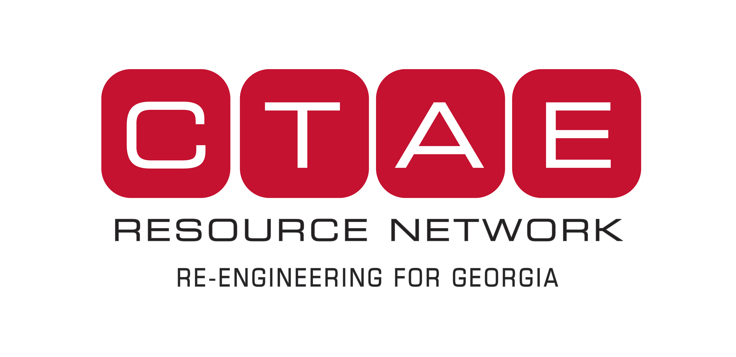
The Community Emergency Response Team (CERT) program helps train people to be better prepared to respond to emergency situations in their communities. When emergencies happen, CERT members can give critical support to first responders, provide immediate assistance to victims, and organize spontaneous volunteers at a disaster site. CERT members can also help with non-emergency projects that help improve the safety of the community.
The CERT course is taught in the community by a trained team of first responders who have completed a CERT Train-the-Trainer course conducted by their state training office for emergency management, or FEMA's Emergency Management Institute (EMI), located in Emmitsburg, Maryland. CERT training includes disaster preparedness, disaster fire suppression, basic disaster medical operations, and light search and rescue operations.
Over the next two years, the CERT program aims to double the number of participants, with over 400,000 individuals completing the 20 plus hours of training. Train-the-Trainer sessions will be held in all 56 states and territories over the next year to expand the program throughout the United States.
First Responders
Notes from http://en.wikipedia.org/wiki/Certified_first_responder
A certified first responder is a person who has completed forty to sixty hours of training in providing prehospital care for medical emergencies. They have more skill than someone who is trained in basic first aid but they are not emergency medical technicians. The term "certified first responder" is not to be confused with "first responder", which is a generic term referring to the first medically trained responder to arrive on scene (police, fire, EMS). In some cases, or states, all that is required, to be an EMS (Emergency Medical Services) technician, is the proper certification. Certified first responders fill the gap between a basic first aid provider and an EMT-Basic. First responder training is a cost-effective way to extend the reach of an emergency medical system, but is not a substitute for EMT-Basic training for those employed to provide emergency medical services on a daily basis.
Emergency Medical Technicians
Notes from http://www.bls.gov/oco/ocos101.htm#training
The EMT-Basic represents the first component of the emergency medical technician system. An EMT trained at this level is prepared to care for patients at the scene of an accident and while transporting patients by ambulance to the hospital under medical direction. The EMT-Basic has the emergency skills to assess a patient’s condition and manage respiratory, cardiac, and trauma emergencies.
The EMT-Intermediate has more advanced training. However, the specific tasks that those certified at this level are allowed to perform varies greatly from State to State.
EMT-Paramedics provide the most extensive pre-hospital care. In addition to carrying out the procedures of the other levels, paramedics may administer drugs orally and intravenously, interpret electrocardiograms (EKGs), perform endotracheal intubations, and use monitors and other complex equipment. However, like EMT-Intermediate, what paramedics are permitted to do varies by State.

